|  |  |
| --- | --- |
| Project name | Tendable |
| Client name | Tendable |
| Reference Document | FRS |
| Creation By | Nikhil Kshirsagar |
| Creation Date | 30-11-2023 |
|  |  |

|  |  |  |  |  |  |  |  |  |
| --- | --- | --- | --- | --- | --- | --- | --- | --- |
| Sr.no | Bug ID | Desription | Steps to Reproduce | Expected Result | Actual Result | S | P | Screenshot |
| 1. | TD-1 | Confirm Accessibility of Top-Level Menus | 1. the "Home" page. 2. Verify the accessibility of the top-level menu "Home." 3. Repeat steps 1-2 for the "Our Story," "Our Solution," and "Why Tendable" pages. | The top-level menus were accessible. | The top-level menus were accessible. |  |  |  |
| 2. | TD-2 | Verify "Request a Demo" Button | 1. the "Home" page. 2. Verify the accessibility of the top-level menu "Home." 3. Repeat steps 1-2 for the "Our Story," "Our Solution," and "Why Tendable" pages. | The "Request a Demo" button was present and active on each top-level menu page. | The "Request a Demo" button should be present and active on each top-level menu page. |  |  |  |
| 3. | TD-3 | Test "Contact Us" Form Submission | 1. Navigate to the "Contact Us" section. 2. Choose the "Marketing" option. 3. Complete the form, excluding the "Message" field. 4. Submit the form. 5. Verify the presence of an error message. | The "Contact Us" form was submitted without the "Message" field, but no error message appeared. | Submitting the "Contact Us" form without the "Message" field should trigger an error message. |  |  | Screenshot no 1 |

**Summary:**

The accessibility and functionality of the top-level menu and the “Request a Demo” button were tested. Additional, the “Contact Us” form was submitted without filling in the “Message” field to check for the appearance of an error message. The issue arises if no error message is displayed in this scenario.

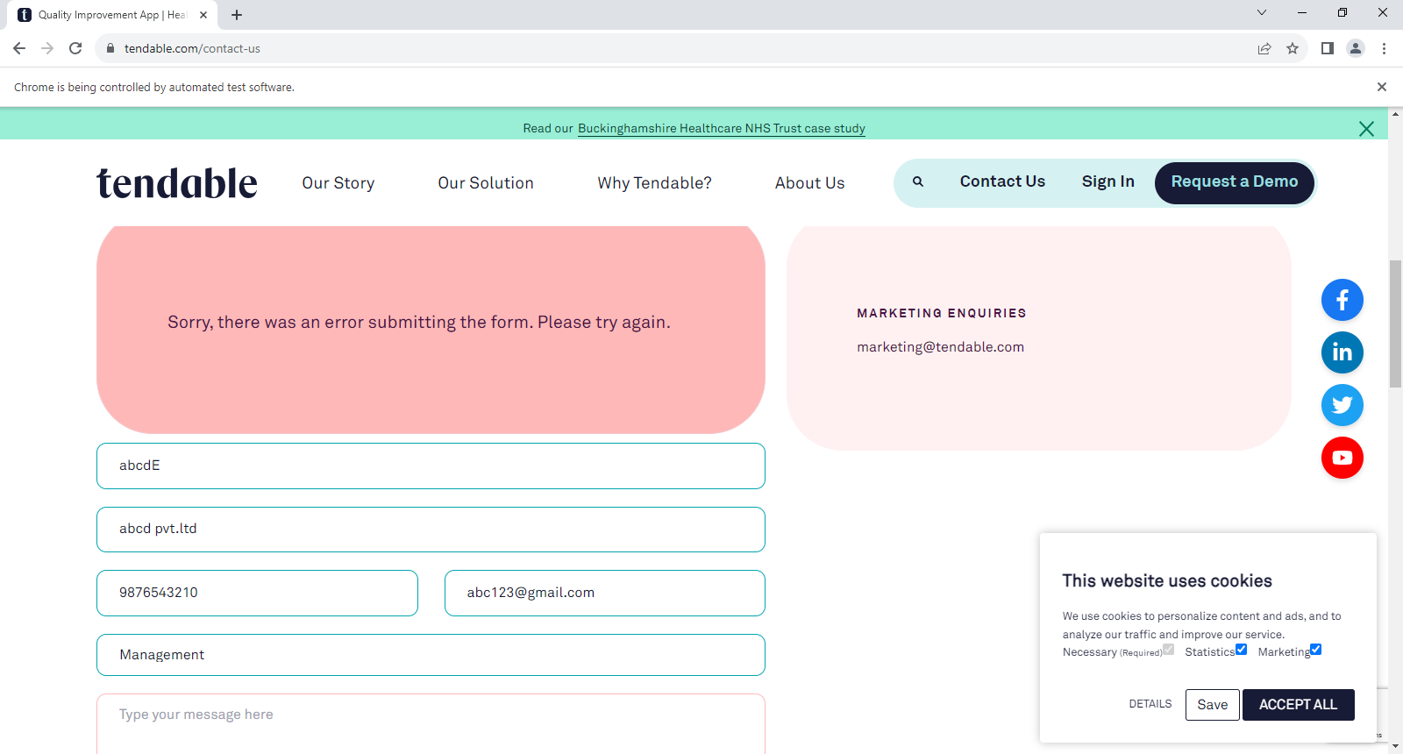

Screenshot no 1: the “Contact Us” form was submitted without filling in the “Message”

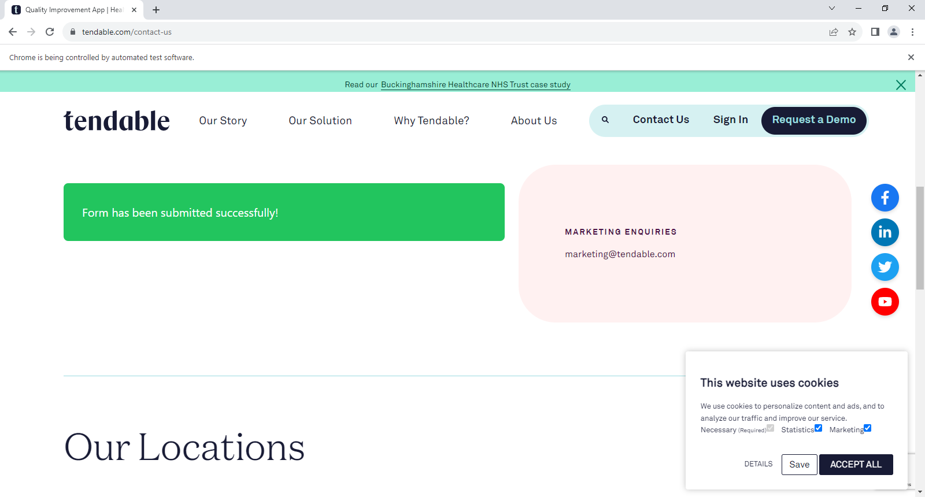

Screenshot : the “Contact Us” form was submitted with filling in the “Message”